Q1 - Week 1 - 10

Page / - last modified by Roelof Zwaan on 2023/03/13 14:37

Week 1 - 10
last modified by Roelof Zwaan
on 2023/03/13 14:37

Table of Contents

Bugfixes
- A certain order of actions and operations in the table view could result in a double unique identifier voor measurement objects, layers and samples
- If there were no labassignments made in your terraindex environment, and a user entered the 'all labassignments' table view, the table would show an infinite load.
- In the groundwater / surface water table views, the field 'Oxygen mg/L' was not visible.
- There were incorrect label translations for the length and width fields on layer level.
- Several small issues when creating new users have been fixed.
- Sometimes duplicate news items were visible in the news widget
- The multi-delete sometimes would not work correctly
- Map functionality not zooming to the searched location
- Verification tool was not working
- When navigating to the export functionality from within the fieldwork app, the user would be shown a white screen
- The borelogs in web functionality was only available in dutch
- Under certain circumstances coordinates could be removed
Features
Analysis Results
- For air sample analysis results in the unit µq/tube a mg/m3 value can be calculated based on the sampled volume of that sample
- Leaching results can be exchanged with SGS and Agrolab and will be visible in terraindex
- Additional component codes for lab results have been added, Terraindex now supports all components up to SIKB ID 7080.
Map Functionality
- The 'Eis voorzorgsmaatregel' element has been added to the KLIC converter
- Appurtenances have been added to the KLIC converter
- KLIC elements are now split on multiple map layers so they can be individually set to visible or turned off
- Groups for map layers have been expanded.
General terraindex improvements
- It is now possible to delete coordinates for measurement points
- Borelogs are now visible in web (without making a report) by clicking the borelog icon on the right of the measurement object overview (See additional explanation at the bottom of this article)
- When tabbing to a next row in the table view changes will be saved
- The measurement point table now also has a field table like the other table views
- The column 'MPNumeric' has been added to the measurement point table view, which shows just the numeric values in a name
- The selected measurement point will now be remembered when switching between table views
- A new table view has been created with shows all lab assignments that have been made within your terraindex environment (See additional explanation at the bottom of this article)
- A new field (state) has been added to the labassignment table (both the project labassignments and the all labassignments table).
Exports
- SIKB 14.7 Export has been created under the exports options
- The mistral 8.7 export has been expanded with additional PFAS components
Reports
- RQT report for Belgium customers has been updated in French. The numeric values will now show without a tab so that the results can be easily imported in the official RQT macro excel
- An additional column to the vlarebo report has been added with the name of the measurement object that the sample originates from.
- The PFAS components have been reordered and renamed for belgium customers in accordance with the CMA lists for PFAS. (Has this not been implemented on your environment? Contact us at service@terraindex.com)
- A fieldwork report for French customers has been created (tableaux d'ouvrage) which contains several tables with fieldwork information
- New Walloon "soil displacement" assessment has been created
- New Vlarema 2.3.2A and 2.3.2B assessments for Belgium have been created
New borelog in web functionality:
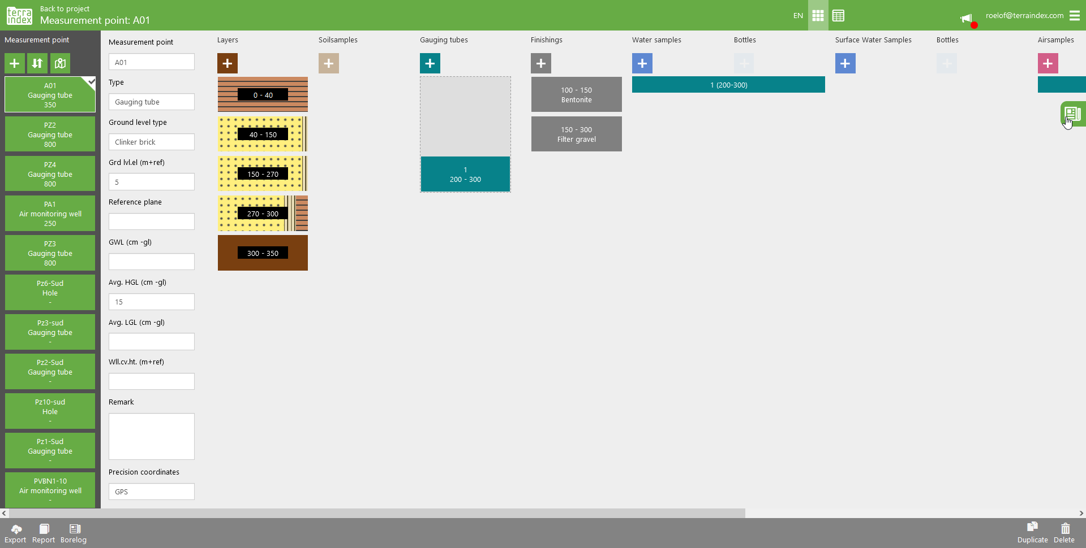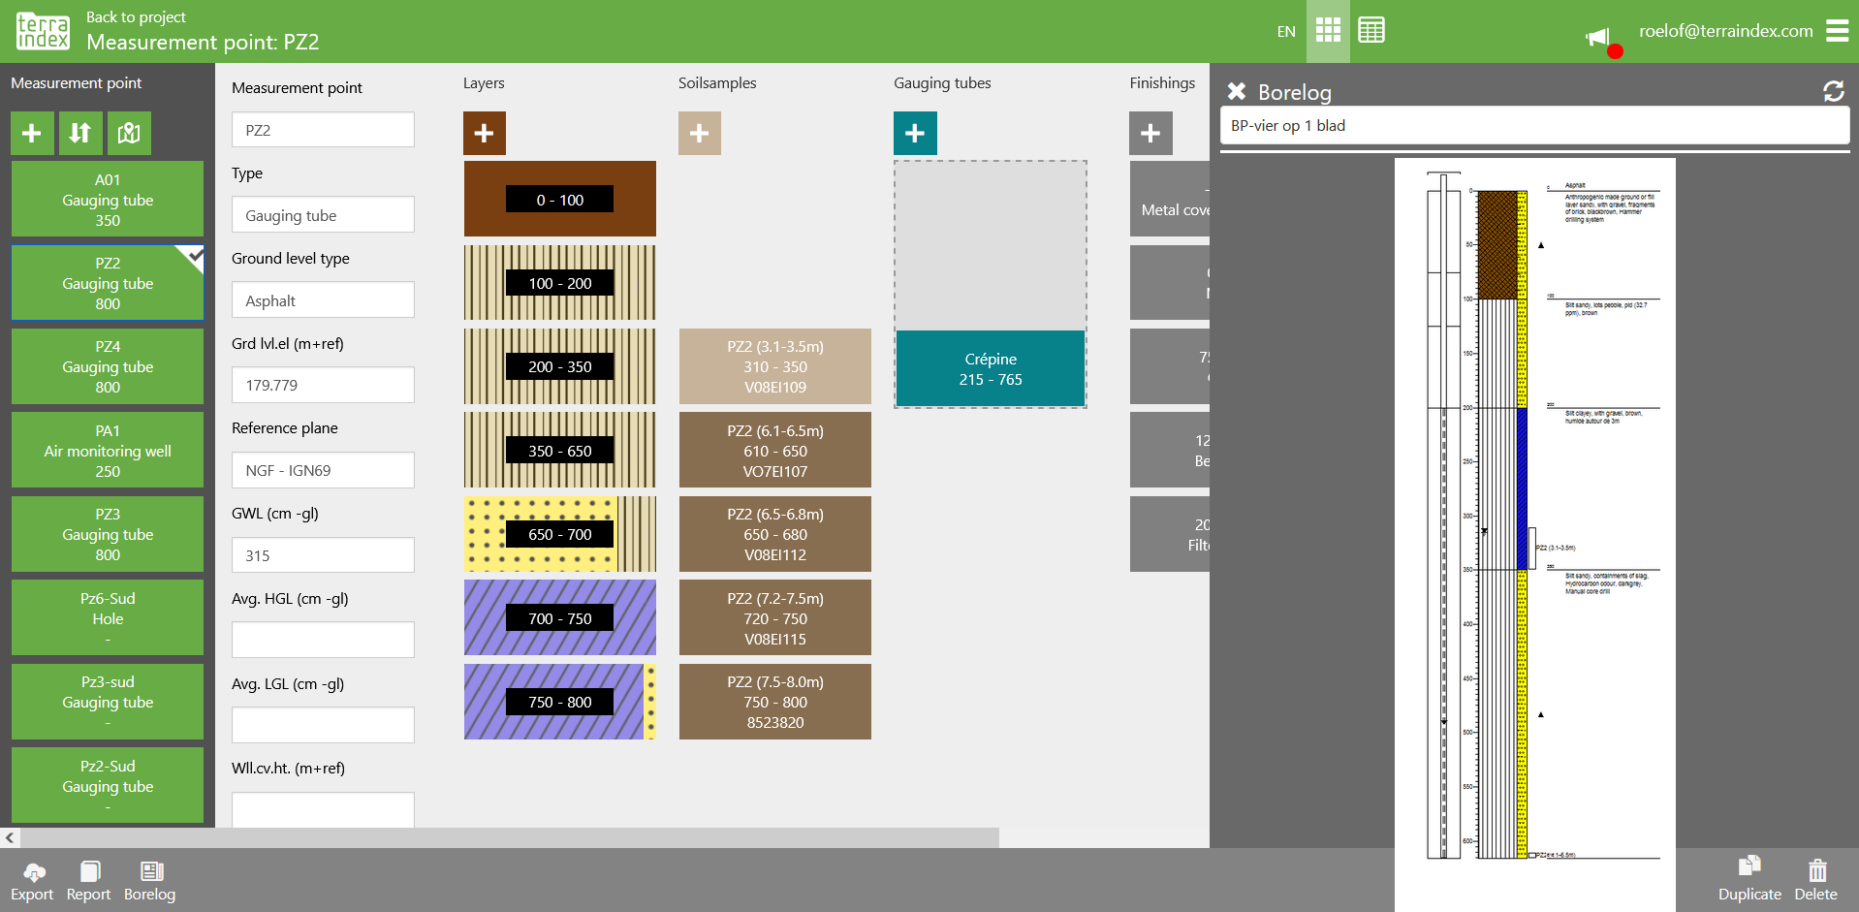
New labassignment table:


