Karakteristieken - Lamination

Page / - last modified by TerraIndex TerraIndex on 2021/09/30 15:20

Lamination
last modified by TerraIndex TerraIndex
on 2021/09/30 15:20

Table of Contents

Lamination is a small-scale sequence of fine layers that occurs in sedimentary rocks.

Lamination
Lamination is a small-scale sequence of fine layers that occurs in sedimentary rocks. Laminae are normally smaller and less pronounced than bedding. Lamination is often regarded as planar structures one centimeter or less in thickness, whereas bedding layers are greater than one centimeter. However, structures from several millimeters to many centimeters have been described as laminae. A single sedimentary rock can have both laminae and beds.
Lamination consists of small differences in the type of sediment that occur throughout the rock. They are caused by cyclic changes in the supply of sediment. These changes can occur in grain size, clay percentage, microfossil content, organic material content or mineral content and often result in pronounced differences in color between the laminae. Weathering can make the differences even more clear.
So a layer can be very laminated. The lamination within a layer can vary enormously.

Lamination
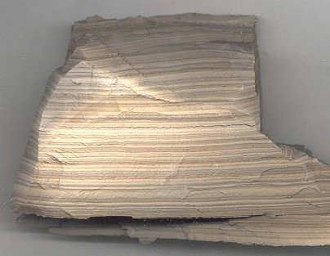
Image | Lamination
Contents
- Lamination
- Lamination

